DBMS UNIT -3 REG NO:

Transaction Concepts

What is a Database Transaction?
A Database Transaction is a logical unit of processing in a DBMS which entails one or more database access operation. In a nutshell, database transactions represent real-world events of any enterprise. All types of database access operation which are held between the beginning and end transaction statements are considered as a single logical transaction in DBMS. During the transaction the database is inconsistent. Only once the database is committed the state is changed from one consistent state to another.
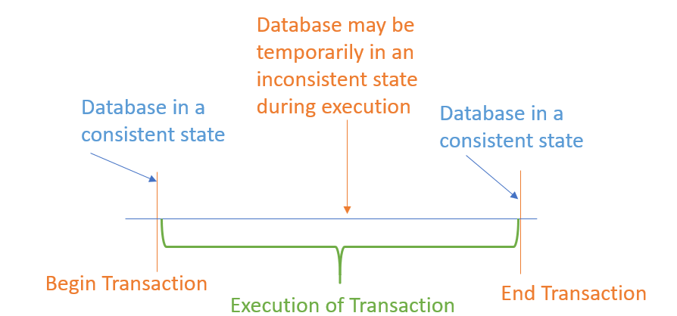

Facts about Database Transactions
- A transaction is a program unit whose execution may or may not change the contents of a database.
- The transaction concept in DBMS is executed as a single unit.
- If the database operations do not update the database but only retrieve data, this type of transaction is called a read-only transaction.
- A successful transaction can change the database from one CONSISTENT STATE to another
- DBMS transactions must be atomic, consistent, isolated and durable
- If the database were in an inconsistent state before a transaction, it would remain in the inconsistent state after the transaction.

Why do you need concurrency in Transactions?
A database is a shared resource accessed. It is used by many users and processes concurrently. For example, the banking system, railway, and air reservations systems, stock market monitoring, supermarket inventory, and checkouts, etc.
Not managing concurrent access may create issues like:Skip Ad
- Hardware failure and system crashes
- Concurrent execution of the same transaction, deadlock, or slow performance

States of Transactions
The various states of a transaction concept in DBMS are listed below:
State | Transaction types
Active State | A transaction enters into an active state when the execution process begins. During this state read or write operations can be performed.
Partially Committed | A transaction goes into the partially committed state after the end of a transaction.
Committed State | When the transaction is committed to state, it has already completed its execution successfully. Moreover, all of its changes are recorded to the database permanently.
Failed State | A transaction considers failed when any one of the checks fails or if the transaction is aborted while it is in the active state.
Terminated State | State of transaction reaches terminated state when certain transactions which are leaving the system can’t be restarted.
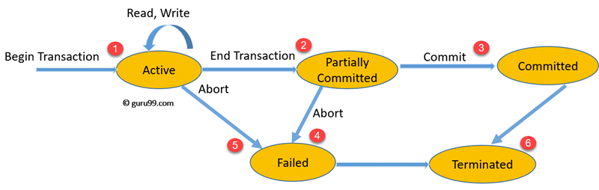
State Transition Diagram for a Database Transaction
Let’s study a state transition diagram that highlights how a transaction moves between these various states.
- Once a transaction states execution, it becomes active. It can issue READ or WRITE operation.
- Once the READ and WRITE operations complete, the transactions becomes partially committed state.
- Next, some recovery protocols need to ensure that a system failure will not result in an inability to record changes in the transaction permanently. If this check is a success, the transaction commits and enters into the committed state.
- If the check is a fail, the transaction goes to the Failed state.
- If the transaction is aborted while it’s in the active state, it goes to the failed state. The transaction should be rolled back to undo the effect of its write operations on the database.
- The terminated state refers to the transaction leaving the system.

ACID Properties

- A transaction is a single logical unit of work which accesses and possibly modifies the contents of a database. Transactions access data using read and write operations.
In order to maintain consistency in a database, before and after the transaction, certain properties are followed. These are called ACID properties.
- 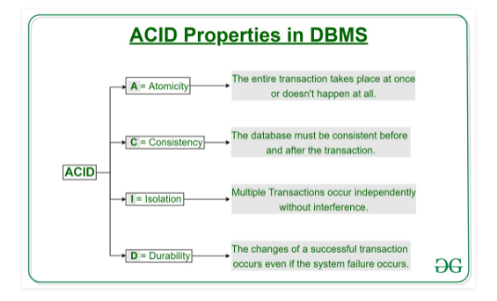
- 1. Atomicity
By this, we mean that either the entire transaction takes place at once or doesn’t happen at all. There is no midway i.e. transactions do not occur partially. Each transaction is considered as one unit and either runs to completion or is not executed at all. It involves the following two operations.
—Abort: If a transaction aborts, changes made to database are not visible.
—Commit: If a transaction commits, changes made are visible.
Atomicity is also known as the ‘All or nothing rule’.
- Consider the following transaction T consisting of T1 and T2: Transfer of 100 from account X to account Y.

- 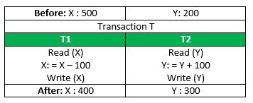
- If the transaction fails after completion of T1 but before completion of T2.( say, after write(X) but before write(Y)), then amount has been deducted from X but not added to Y. This results in an inconsistent database state. Therefore, the transaction must be executed in entirety in order to ensure correctness of database state.

- 2. Consistency
This means that integrity constraints must be maintained so that the database is consistent before and after the transaction. It refers to the correctness of a database. Referring to the example above,
The total amount before and after the transaction must be maintained.
Total before T occurs = 500 + 200 = 700.
Total after T occurs = 400 + 300 = 700.
Therefore, database is consistent. Inconsistency occurs in case T1 completes but T2 fails. As a result T is incomplete.
- 3. Isolation
This property ensures that multiple transactions can occur concurrently without leading to the inconsistency of database state. Transactions occur independently without interference. Changes occurring in a particular transaction will not be visible to any other transaction until that particular change in that transaction is written to memory or has been committed. This property ensures that the execution of transactions concurrently will result in a state that is equivalent to a state achieved these were executed serially in some order.
Let X= 500, Y = 500.
Consider two transactions T and T”.
- 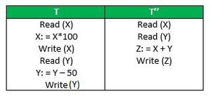
- Suppose T has been executed till Read (Y) and then T’’ starts. As a result , interleaving of operations takes place due to which T’’ reads correct value of X but incorrect value of Y and sum computed by
T’’: (X+Y = 50, 000+500=50, 500)
is thus not consistent with the sum at end of transaction:
T: (X+Y = 50, 000 + 450 = 50, 450).
This results in database inconsistency, due to a loss of 50 units. Hence, transactions must take place in isolation and changes should be visible only after they have been made to the main memory.
- 4. Durability:
This property ensures that once the transaction has completed execution, the updates and modifications to the database are stored in and written to disk and they persist even if a system failure occurs. These updates now become permanent and are stored in non-volatile memory. The effects of the transaction, thus, are never lost.
- The ACID properties, in totality, provide a mechanism to ensure correctness and consistency of a database in a way such that each transaction is a group of operations that acts a single unit, produces consistent results, acts in isolation from other operations and updates that it makes are durably stored.

Schedules
We know that transactions are set of instructions and these instructions perform operations on database. When multiple transactions are running concurrently then there needs to be a sequence in which the operations are performed because at a time only one operation can be performed on the database. This sequence of operations is known as Schedule.

DBMS Schedule example
The following sequence of operations is a schedule. Here we have two transactions T1 & T2 which are running concurrently. This schedule determines the exact order of operations that are going to be performed on database. In this example, all the instructions of transaction T1 are executed before the instructions of transaction T2, however this is not always necessary and we can have various types of schedules which we will discuss below
T1 T2
---- ----
R(X)
W(X)
R(Y)
R(Y)
R(X)
W(Y)

Types of Schedules in DBMS
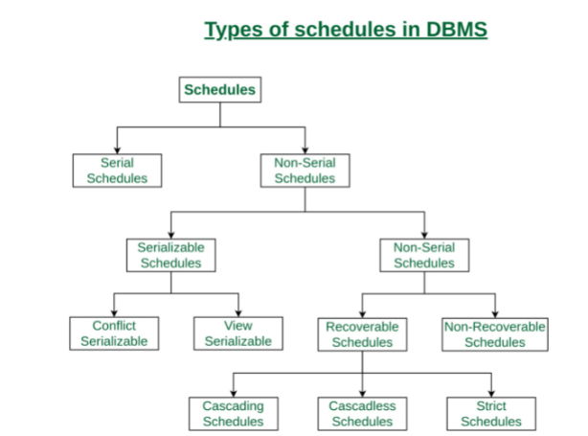

1. Serial Schedule
In Serial schedule, a transaction is executed completely before starting the execution of another transaction. In other words, you can say that in serial schedule, a transaction does not start execution until the currently running transaction finished execution. This type of execution of transaction is also known as non-interleaved execution. The example we have seen above is the serial schedule.
Lets take another example.
Serial Schedule example
Here R refers to the read operation and W refers to the write operation. In this example, the transaction T2 does not start execution until the transaction T1 is finished.
T1 T2
---- ----
R(A)
R(B)
W(A)
commit
R(B)
R(A)
W(B)
commit

2. Non-Serial Schedule:
This is a type of Scheduling where the operations of multiple transactions are interleaved. This might lead to a rise in the concurrency problem. The transactions are executed in a non-serial manner, keeping the end result correct and same as the serial schedule. Unlike the serial schedule where one transaction must wait for another to complete all its operation, in the non-serial schedule, the other transaction proceeds without waiting for the previous transaction to complete. This sort of schedule does not provide any benefit of the concurrent transaction. It can be of two types namely, Serializable and Non-Serializable Schedule.

The Non-Serial Schedule can be divided further into Serializable and Non-Serializable.
3. Non-Serializable:
The non-serializable schedule is divided into two types, Recoverable and Non-recoverable Schedule.
    - Recoverable Schedule:
Schedules in which transactions commit only after all transactions whose changes they read commit are called recoverable schedules. In other words, if some transaction T_{j} is reading value updated or written by some other transaction T_{i}, then the commit of T_{j} must occur after the commit of T_{i}.
Example – Consider the following schedule involving two transactions T₁ and T₂.
T₁ | T₂
R(A)
W(A)
 | W(A)
 | R(A)
commit
 | Commit
This is a recoverable schedule since T₁ commits before T₂, that makes the value read by T₂ correct.
There can be three types of recoverable schedule:
      - Cascading Schedule:
Also called Avoids cascading aborts/rollbacks (ACA). When there is a failure in one transaction and this leads to the rolling back or aborting other dependent transactions, then such scheduling is referred to as Cascading rollback or cascading abort. Example:
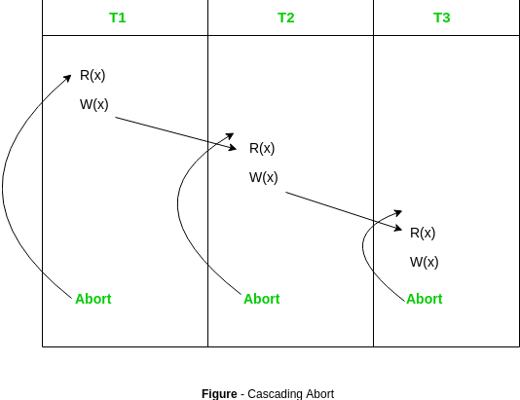
      - Cascadeless Schedule:
If in a schedule, a transaction is not allowed to read a data item until the last transaction that has written it is committed or aborted, then such a schedule is called as a Cascadeless Schedule.
In other words,
- Cascadeless schedule allows only committed read operations.
- Therefore, it avoids cascading roll back and thus saves CPU time.

Example: Consider the following schedule involving two transactions T₁ and T₂.
T₁ | T₂
R(A)
W(A)
 | W(A)
commit
 | R(A)
 | Commit
This schedule is cascadeless. Since the updated value of A is read by T₂ only after the updating transaction i.e. T₁ commits.

Example: Consider the following schedule involving two transactions T₁ and T₂.
T₁ | T₂
R(A)
W(A)
 | R(A)
 | W(A)
abort
 | Abort
It is a recoverable schedule but it does not avoid cascading aborts. It can be seen that if T₁ aborts, T₂ will have to be aborted too in order to maintain the correctness of the schedule as T₂ has already read the uncommitted value written by T₁.

Strict Schedule:
If in a schedule, a transaction is neither allowed to read nor write a data item until the last transaction that has written it is committed or aborted, then such a schedule is called as a Strict Schedule.
In other words,
- Strict schedule allows only committed read and write operations.
- Clearly, strict schedule implements more restrictions than cascadeless schedule.
Example: Consider the following schedule involving two transactions T₁ and T₂.
T₁ | T₂
R(A)
 | R(A)
W(A)
commit
 | W(A)
 | R(A)
 | Commit
This is a strict schedule since T₂ reads and writes A which is written by T₁ only after the commit of T₁.
    - Non-Recoverable Schedule:
Example: Consider the following schedule involving two transactions T₁ and T₂.
T₁ | T₂
R(A)
W(A)
 | W(A)
 | R(A)
 | Commit
abort
T₂ read the value of A written by T₁, and committed. T₁ later aborted, therefore the value read by T₂ is wrong, but since T₂ committed, this schedule is non-recoverable.

Serializability
When multiple transactions are running concurrently then there is a possibility that the database may be left in an inconsistent state. Serializability is a concept that helps us to check which schedules are serializable. A serializable schedule is the one that always leaves the database in consistent state.

4.1. What is a serializable schedule?
A serializable schedule always leaves the database in consistent state. A serial schedule is always a serializable schedule because in serial schedule, a transaction only starts when the other transaction finished execution. However a non-serial schedule needs to be checked for Serializability.
A non-serial schedule of n number of transactions is said to be serializable schedule, if it is equivalent to the serial schedule of those n transactions. A serial schedule doesn’t allow concurrency, only one transaction executes at a time and the other starts when the already running transaction finished.

4.2 .Testing of Serializability
To test the serializability of a schedule, we can use the serialization graph.
Suppose, a schedule S. For schedule S, construct a graph called as a precedence graph. It has a pair G = (V, E), where E consists of a set of edges, and V consists of a set of vertices. The set of vertices contain all the transactions participating in the S schedule. The set of edges contains all edges Ti ->Tj for which one of the following three conditions satisfy:
- Create a node Ti ? Tj if Ti transaction executes write (Q) before Tj transaction executes read (Q).
- Create a node Ti ? Tj if Ti transaction executes read (Q) before Tj transaction executes write (Q).
- Create a node Ti ? Tj if Ti transaction executes write (Q) before Tj transaction executes write (Q).
Schedule S:
Time | Transaction T1 | Transaction T2
T1 | Read(A)
T2 | A=A+50
T3 | Write(A)
T4 |  | Read(A)
T5 |  | A+A+100
T6 |  | Write(A)

Precedence graph of Schedule S
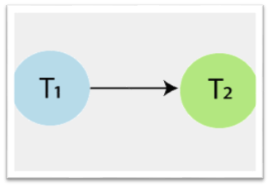
In above precedence graph of schedule S, contains two vertices T1 and T2, and a single edge T1? T2, because all the instructions of T1 are executed before the first instruction of T2 is executed. If a precedence graph for any schedule contains a cycle, then that schedule is non-serializable. If the precedence graph has no cycle, then the schedule is serializable. So, schedule S is serializable (i.e., serial schedule) because the precedence graph has no cycle.

Schedule S1:
Time | Transaction T1 | Transaction T2
T1 | Read(A)
T2 |  | Read(A)
T3 |  | Write(A)
T4 | A=A+50
T5 | Write(A)

Precedence graph of Schedule S1
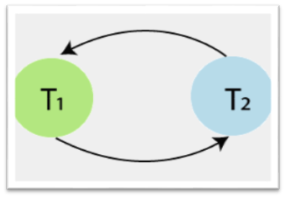
In above precedence graph of schedule S1, contains two vertices T1 and T2, and edges T1? T2 and T2? T1. In this Schedule S1, operations of T1 and T2 transaction are present in an interleaved manner. The precedence graph contains a cycle, that’s why schedule S1 is non-serializable.

4.3.Types of Serializability
There are two types of Serializability.
1. ConflictSerializability
2. View Serializability

4.3.1.Conflict Serializability:

Conflict Serializability is one of the type of Serializability, which can be used to check whether a non-serial schedule is conflict serializable or not.

What is Conflict Serializability?
A schedule is called conflict serializable if we can convert it into a serial schedule after swapping its non-conflicting operations.

Conflicting operations
Two operations are said to be in conflict, if they satisfy all the following three conditions:
1. Both the operations should belong to different transactions.
2. Both the operations are working on same data item.
3. At least one of the operation is a write operation.
Let's see some examples to understand this:
Example 1: Operation W(X) of transaction T1 and operation R(X) of transaction T2 are conflicting operations, because they satisfy all the three conditions mentioned above. They belong to different transactions, they are working on same data item X, one of the operation in write operation.
Example 2: Similarly Operations W(X) of T1 and W(X) of T2 are conflicting operations.
Example 3: Operations W(X) of T1 and W(Y) of T2 are non-conflicting operations because both the write operations are not working on same data item so these operations don’t satisfy the second condition.
Example 4: Similarly R(X) of T1 and R(X) of T2 are non-conflicting operations because none of them is write operation.
Example 5: Similarly W(X) of T1 and R(X) of T1 are non-conflicting operations because both the operations belong to same transaction T1.

Conflict Equivalent Schedules
Two schedules are said to be conflict Equivalent if one schedule can be converted into other schedule after swapping non-conflicting operations.

Conflict Serializable check
Let's check whether a schedule is conflict serializable or not. If a schedule is conflict Equivalent to its serial schedule then it is called Conflict Serializable schedule. Lets take few examples of schedules.

Example of Conflict Serializability
Let's consider this schedule:
T1 T2
----- ------
R(A)
R(B)
R(A)
R(B)
W(B)
W(A)

To convert this schedule into a serial schedule we must have to swap the R(A) operation of transaction T2 with the W(A) operation of transaction T1. However we cannot swap these two operations because they are conflicting operations, thus we can say that this given schedule is not Conflict Serializable.
Let's take another example:
T1 T2
----- ------
R(A)
R(A)
R(B)
W(B)
R(B)
W(A)

Lets swap non-conflicting operations:
After swapping R(A) of T1 and R(A) of T2 we get:
T1 T2
----- ------
R(A)
R(A)
R(B)
W(B)
R(B)
W(A)
After swapping R(A) of T1 and R(B) of T2 we get:
T1 T2
----- ------
R(A)
R(B)
R(A)
W(B)
R(B)
W(A)
After swapping R(A) of T1 and W(B) of T2 we get:
T1 T2
----- ------
R(A)
R(B)
W(B)
R(A)
R(B)
W(A)
We finally got a serial schedule after swapping all the non-conflicting operations so we can say that the given schedule is Conflict Serializable.

4.3.2.View Serializability
It is a type of serializability that can be used to check whether the given schedule is view serializable or not. A schedule called as a view serializable if it is view equivalent to a serial schedule.
View Equivalent
Two schedules S1 and S2 are said to be view equivalent if both satisfy the following conditions:
1. Initial read
An initial read of the data item in both the schedule must be same. For example, lets two schedule S1 and S2. If transaction T1 reads the data item A in schedule S1, then in schedule S2 transaction T1 also reads A.

Schedule S1:
Time | Transaction T1 | Transaction T2
t1 | Read(X)
t2 |  | Write(X)

Schedule S2:
Time | Transaction T1 | Transaction T2
t1 |  | Write(X)
t2 | Read(X)
Above two schedules, S1 and S2 are view equivalent, because initial read instruction in S1 is done by T1 transaction and in schedule S2 is also done by transaction T2.
2. Updated Read
In schedule S1, if the transaction T_{i} is reading the data item A which is updated by transaction T_{j}, then in schedule S2 also, T_{i} should read data item A which is updated by T_{j}.

Schedule S1:
Time | Transaction T1 | Transaction T2
t1 | Write(X)
t2 |  | Read(X)
Schedule S2:
Time | Transaction T1 | Transaction T2
t1 | Write(X)
t2 |  | Read(X)
Above two schedules S1 and S2 are view equivalent because in schedule S1 transaction T2 reads the data item A which is updated by T1 and in schedule S2 T2 also reads the data item A which is updated by T1.
3. Final write
The final write operation on each data item in both the schedule must be same. In a schedule S1, if a transaction T1 updates data item A at last then in schedule S2, final writes operations should also be done by T1 transaction.
Schedule S1:
Time | Transaction T1 | Transaction T2 | Transaction T3
t1 |  |  | Write(X)
t2 |  | Read(X)
t3 | Write(X)
Schedule S2:
Time | Transaction T1 | Transaction T2 | Transaction T3
t1 |  |  | Write(X)
t2 |  | Read(X)
t3 | Write(X)
Above two schedules, S1 and S2 are view equivalent because final write operation in schedule S1 is done by T1 and in S2, T1 also does the final write operation.
View Serializable
A schedule is said to be a view serializable if that schedule is view equivalent to a serial schedule.
View Serializable example
Schedule S1 (Non-Serial Schedule):
Time | Transaction T1 | Transaction T2
t1 | Read(X)
t2 | Write(X)
t3 |  | Read(X)
t4 |  | Write(X)
t5 | Read(Y)
t6 | Write(Y)
t7 |  | Read(Y)
t8 |  | Write(Y)
Schedule S2 (Serial Schedule):
Time | Transaction T1 | Transaction T2
t1 | Read(X)
t2 | Write(X)
t3 | Read(Y)
t4 | Write(Y)
t5 |  | Read(X)
t6 |  | Write(X)
t7 |  | Read(Y)
t8 |  | Write(Y)
Note: S2 is the serial schedule of S1. If we can prove that both the schedule are view equivalent, then we can say that S1 schedule is a view serializable schedule.
Now, check the three conditions of view serializability for this example:
1. Initial Read
In S1 schedule, T1 transaction first reads the data item X. In Schedule S2 also transaction T1 first reads the data item X.
Now, check for Y. In schedule S1, T1 transaction first reads the data item Y. In schedule S2 also the first read operation on data item Y is performed by T1.
We checked for both data items X and Y, and the initial read condition is satisfied in schedule S1 & S2.
2. Updated Read
In Schedule S1, transaction T2 reads the value of X, which is written by transaction T1. In Schedule S2, the same transaction T2 reads the data item X after T1 updates it.
Now check for Y. In Schedule S1, transaction T2 reads the value of Y, which is written by T1. In S2, the same transaction T2 reads the value of data item Y after T1 writes it.
The update read condition is also satisfied for both the schedules S1 and S2.
3. Final Write
In schedule S1, the final write operation on data item X is done by transaction T2. In schedule S2 also transaction T2 performs the final write operation on X.
Now, check for data item Y. In schedule S1, the final write operation on Y is done by T2 transaction. In schedule S2, a final write operation on Y is done by T2.
We checked for both data items X and Y, and the final write condition is also satisfied for both the schedule S1 & S2.

Hence, all the three conditions are satisfied in this example, which means Schedule S1 and S2 are view equivalent. Also, it is proved that schedule S2 is the serial schedule of S1. Thus we can say that the S1 schedule is a view serializable schedule.

Concurrency Control
Concurrency Control in Database Management System is a procedure of managing simultaneous operations without conflicting with each other. It ensures that Database transactions are performed concurrently and accurately to produce correct results without violating data integrity of the respective Database.

Concurrent access is quite easy if all users are just reading data. There is no way they can interfere with one another. Though for any practical Database, it would have a mix of READ and WRITE operations and hence the concurrency is a challenge.

DBMS Concurrency Control is used to address such conflicts, which mostly occur with a multi-user system. Therefore, Concurrency Control is the most important element for proper functioning of a Database Management System where two or more database transactions are executed simultaneously, which require access to the same data.

Concurrent Execution in DBMS
- In a multi-user system, multiple users can access and use the same database at one time, which is known as the concurrent execution of the database. It means that the same database is executed simultaneously on a multi-user system by different users.
- While working on the database transactions, there occurs the requirement of using the database by multiple users for performing different operations, and in that case, concurrent execution of the database is performed.
- The thing is that the simultaneous execution that is performed should be done in an interleaved manner, and no operation should affect the other executing operations, thus maintaining the consistency of the database. Thus, on making the concurrent execution of the transaction operations, there occur several challenging problems that need to be solved.

Advantages
The advantages of concurrency control are as follows −
- Waiting time will be decreased.
- Response time will decrease.
- Resource utilization will increase.
- System performance & Efficiency is increased.

Potential problems of Concurrency
Here, are some issues which you will likely to face while using the DBMS Concurrency Control method:
- Lost Updates occur when multiple transactions select the same row and update the row based on the value selected
- Uncommitted dependency issues occur when the second transaction selects a row which is updated by another transaction (dirty read)
- Non-Repeatable Read occurs when a second transaction is trying to access the same row several times and reads different data each time.
- Incorrect Summary issue occurs when one transaction takes summary over the value of all the instances of a repeated data-item, and second transaction update few instances of that specific data-item. In that situation, the resulting summary does not reflect a correct result.
Need for Concurrency
Following are the purposes of concurrency control –
- To ensure isolation
- To resolve read-write or write-write conflicts
- To preserve consistency of database
Concurrent execution of transactions over shared database creates several data integrity and consistency problems – these are

(1) Lost Update Problem : This problem occurs when two transactions that access the same database items have their operations interleaved in a way that makes the value of some database item incorrect.

For example – Consider following transactions
(1) Salary of Employee is read during transaction T1.
(2) Salary of Employee is read by another transaction T2.
(3) During transaction T1, the salary is incremented by ` 200
(4) During transaction T2, the salary is incremented by ` 500
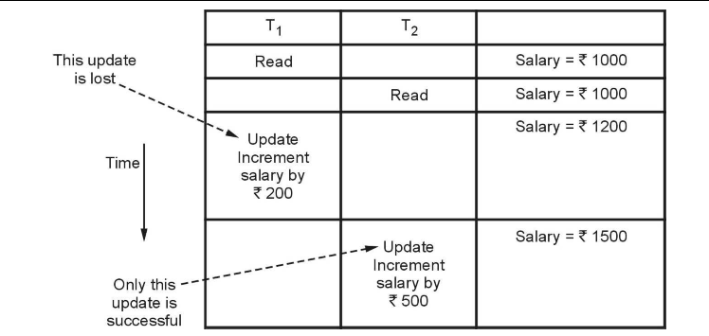
The result of the above sequence is that the update made by transaction T1 is completely lost. There for this problem is called as lost update problem.

(2) Dirty Read or Uncommited Read Problem : The dirty read is a situation in which one transaction reads the data immediately after the write operation of previous
transaction.
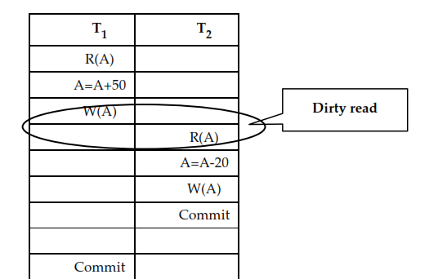
For example – Consider following transactions -
Assume initially salary is = ` 1000

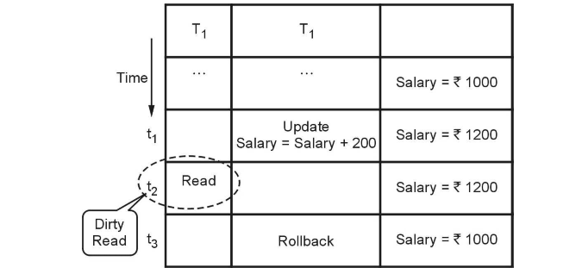

(1) At the time t1, the transaction T2 updates the salary to `1200
(2) This salary is read at time t2 by transaction T1. Obviously it is 1200
(3) But at the time t3, the transaction T2 performs Rollback by undoing the changes made by T1 and T2 at time t1 and t2.
(4) Thus the salary again becomes = ` 1000. This situation leads to Dirty Read or Uncommited Read because here the read made at time t2(immediately after update of another transaction) becomes a dirty read.

(3) Non-repeatable read Problem
This problem is also known as inconsistent analysis problem. This problem occurs when a particular transaction sees two different values for the same row within its lifetime. For example –
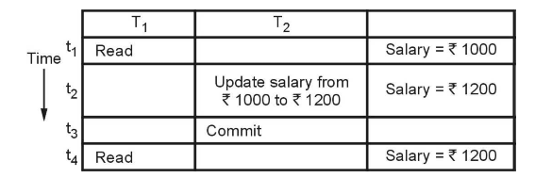
(1) At time t1, the transaction T1 reads the salary as ` 1000
(2) At time t2 the transaction T2 reads the same salary as ` 1000 and updates it to `1200
(3) Then at time t3, the transaction T2 gets committed.
(4) Now when the transaction T1 reads the same salary at time t4, it gets different value than what it had read at time t1. Now, transaction T1 cannot repeat its reading operation. Thus inconsistent values are obtained.
Hence the name of this problem is non-repeatable read or inconsistent analysis problem.

(4) Phantom read Problem
The phantom read problem is a special case of non repeatable read problem. This is a problem in which one of the transaction makes the changes in the database system and due to these changes another transaction cannot read the data item which it has read just recently.
For example –
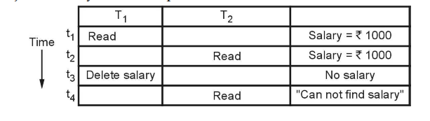

(1) At time t1 , the transaction T1 reads the value of salary as 1000
(2) At time t2, the transaction T2 reads the value of the same salary as ` 1000
(3) At time t3, the transaction T1 deletes the variable salary.
(4) Now at time t4, when T2 again reads the salary it gets error. Now transaction T2 cannot identify the reason why it is not getting the salary value which is read just fewtime back.
This problem occurs due to changes in the database and is called phantom read
problem.

Locking Protocols
Lock Based Protocols in DBMS is a mechanism in which a transaction cannot Read or Write the data until it acquires an appropriate lock. Lock based protocols help to eliminate the concurrency problem in DBMS for simultaneous transactions by locking or isolating a particular transaction to a single user.
A lock is a data variable which is associated with a data item. This lock signifies that operations that can be performed on the data item. Locks in DBMS help synchronize access to the database items by concurrent transactions.
All lock requests are made to the concurrency-control manager. Transactions proceed only once the lock request is granted.
Binary Locks: A Binary lock on a data item can either locked or unlocked states.
Shared/exclusive: This type of locking mechanism separates the locks in DBMS based on their uses. If a lock is acquired on a data item to perform a write operation, it is called an exclusive lock.
1. Shared Lock (S):
A shared lock is also called a Read-only lock. With the shared lock, the data item can be shared between transactions. This is because you will never have permission to update data on the data item.
For example, consider a case where two transactions are reading the account balance of a person. The database will let them read by placing a shared lock. However, if another transaction wants to update that account’s balance, shared lock prevent it until the reading process is over.
2. Exclusive Lock (X):
With the Exclusive Lock, a data item can be read as well as written. This is exclusive and can’t be held concurrently on the same data item. X-lock is requested using lock-x instruction. Transactions may unlock the data item after finishing the ‘write’ operation.
For example, when a transaction needs to update the account balance of a person. You can allows this transaction by placing X lock on it. Therefore, when the second transaction wants to read or write, exclusive lock prevent this operation
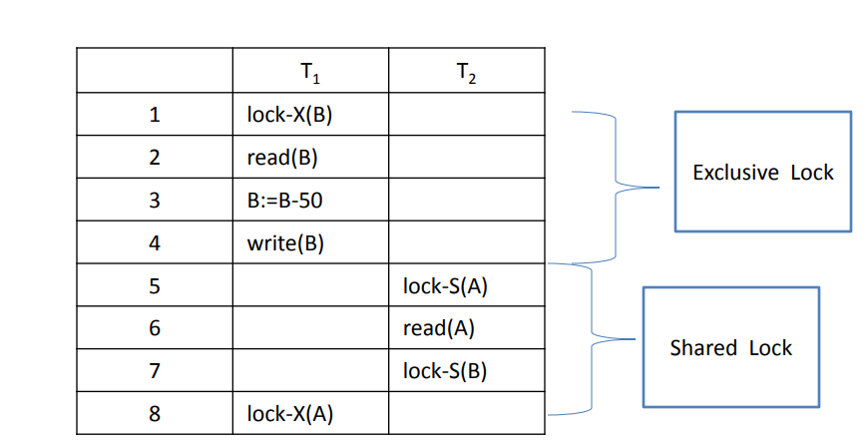
3. Simplistic Lock Protocol
This type of lock-based protocols allows transactions to obtain a lock on every object before beginning operation. Transactions may unlock the data item after finishing the ‘write’ operation.
4. Pre-claiming Locking
Pre-claiming lock protocol helps to evaluate operations and create a list of required data items which are needed to initiate an execution process. In the situation when all locks are granted, the transaction executes. After that, all locks release when all of its operations are over.
Starvation
Starvation is the situation when a transaction needs to wait for an indefinite period to acquire a lock.
Following are the reasons for Starvation:
- When waiting scheme for locked items is not properly managed
- In the case of resource leak
- The same transaction is selected as a victim repeatedly
Lock Compatibility Matrix
- A transaction can be granted lock on a data item if the requested lock is found compatible with the locks on the data item from other transactions
- Multiple number of transactions can have shared locks on any data item. In case any transaction holds exclusive lock on the data item, no other transactions can hold lock on it
- All incompatible locks by other transactions must be released and the requested transaction has to wait if a lock is not granted

Two Phase Locking Protocol

Two Phase Locking Protocol also known as 2PL protocol is a method of concurrency control in DBMS that ensures serializability by applying a lock to the transaction data which blocks other transactions to access the same data simultaneously. Two Phase Locking protocol helps to eliminate the concurrency problem in DBMS.

This locking protocol divides the execution phase of a transaction into three different parts.
- In the first phase, when the transaction begins to execute, it requires permission for the locks it needs.
- The second part is where the transaction obtains all the locks. When a transaction releases its first lock, the third phase starts.
- In this third phase, the transaction cannot demand any new locks. Instead, it only releases the acquired locks.
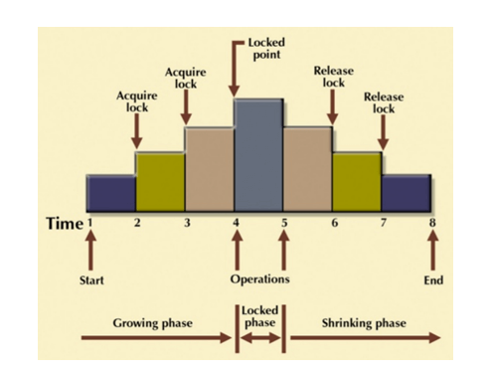
The Two-Phase Locking protocol allows each transaction to make a lock or unlock request in two steps:
- Growing Phase: In this phase transaction may obtain locks but may not release any locks.
- Shrinking Phase: In this phase, a transaction may release locks but not obtain any new lock
It is true that the 2PL protocol offers serializability. However, it does not ensure that deadlocks do not happen.
Example:
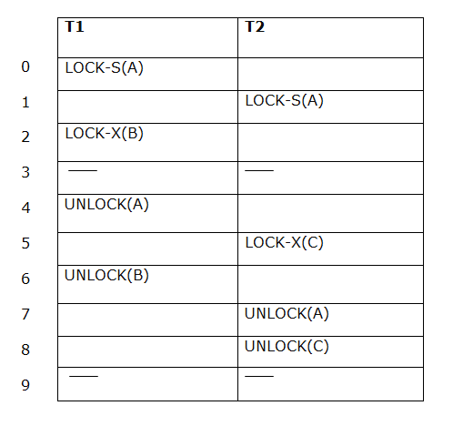
The following way shows how unlocking and locking work with 2-PL.
Transaction T1:
- Growing phase: from step 1-3
- Shrinking phase: from step 5-7
- Lock point: at 3
Transaction T2:
- Growing phase: from step 2-6
- Shrinking phase: from step 8-9
- Lock point: at 6
Types:
1.Strict two phrase locking protocol
2. Rigorous two phrase locking protocol

1.Strict Two-Phase Locking Method
Strict-Two phase locking system is almost similar to 2PL. The only difference is that Strict-2PL never releases a lock after using it. It holds all the locks until the commit point and releases all the locks at one go when the process is over.

2.Rigorous two phase locking protocol
A transaction cannot release any lock either shared or exclusive until it commits.
The 2PL protocol guarantees serializability, but cannot guarantee that deadlock will not happen.

Example
Let T1 and T2 are two transactions.
T1=A+B and T2=B+A
T1 | T2
Lock-X(A) | Lock-X(B)
Read A; | Read B;
Lock-X(B) | Lock-X(A)
Here,
Lock-X(B) : Cannot execute Lock-X(B) since B is locked by T2.
Lock-X(A) : Cannot execute Lock-X(A) since A is locked by T1.
In the above situation T1 waits for B and T2 waits for A. The waiting time never ends. Both the transaction cannot proceed further at least any one releases the lock voluntarily. This situation is called deadlock.

Lock conversion
Lock conversion is a mechanism in two phase locking mechanism - which allows
conversion of shared lock to exclusive lock or exclusive lock to shared lock.

Method of Conversion :
First Phase :
o can acquire a lock-S on item
o can acquire a lock-X on item
o can convert a lock-S to a lock-X (upgrade)
Second Phase :
o can release a lock-S
o can release a lock-X
o can convert a lock-X to a lock-S (downgrade)
This protocol assures serializability. But still relies on the programmer to insert the various locking instructions.
For example – Consider following two transactions –
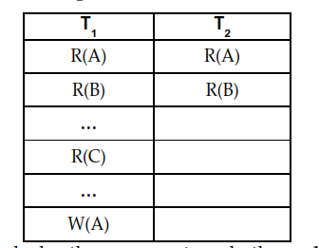
Here if we start applying locks, then we must apply the exclusive lock on data item A, because we have to read as well as write on data item A. Another transaction T2 does not get shared lock on A until transaction T1 performs write operation on A. Since transaction T1 needs exclusive lock only at the end when it performs write operation on A, it is better if T1 could initially lock A in shared mode and then later change it to exclusive mode lock when it performs write operation. In such situation, the lock conversion mechanism becomes useful.

When we convert the shared mode lock to exclusive mode then it is called upgrading
and when we convert exclusive mode lock to shared mode then it is called downgrading.

Also note that upgrading takes place only in growing phase and downgrading takes place only in shrinking phase. Thus we can refine above transactions using lock
conversion mechanism as follows –
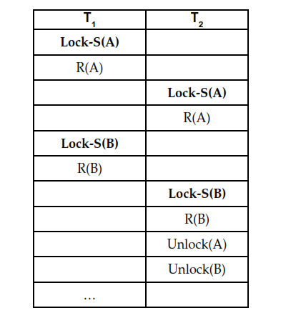
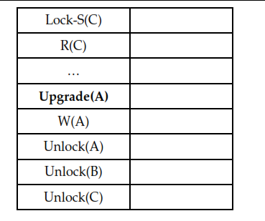
Transaction State
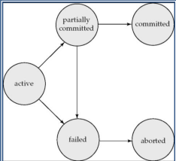
• Active – the initial state; the transaction stays in this state while it is executing
• Partially committed – after the final statement has been executed.
• Failed -- after the discovery that normal execution can no longer proceed.
• Aborted – after the transaction has been rolled back and the database restored to its state prior to the start of the transaction. Two options after it has been aborted:
o restart the transaction
o kill the transaction
• Committed – after successful completion

Log
• Log is a history of actions executed by a database management system to guarantee ACID properties over crashes or hardware failures.
• Physically, a log is a file of updates done to the database, stored in stable storage.

Log rule
– A log records for a given database update must be physically written to the log, before the update physically written to the database.
– All other log record for a given transaction must be physically written to the log, before the commit log record for the transaction is physically written to the log.
– Commit processing for a given transaction must not complete until the commit log record for the transaction is physically written to the log.

System log
– [ Begin transaction ,T ]
– [ write_item , T, X , oldvalue,newvalue]
– [read_item,T,X]
– [commit,T]
– [abort,T]

TWO - PHASE COMMIT
• Assumes fail-stop model – failed sites simply stop working, and do not cause any other harm, such as sending incorrect messages to other sites.
• Execution of the protocol is initiated by the coordinator after the last step of the transaction has been reached.
• The protocol involves all the local sites at which the transaction executed
• Let T be a transaction initiated at site Si, and let the transaction coordinator at Si,by Ci,

Phase 1: Obtaining a Decision (prepare)
• Coordinator asks all participants to prepare to commit transaction Ti

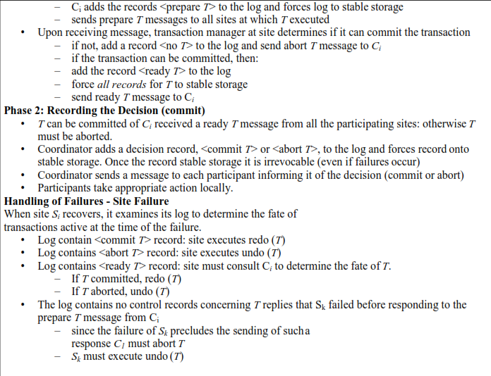
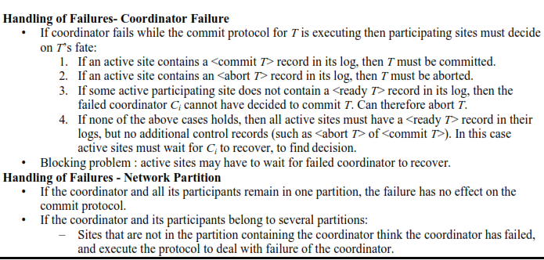
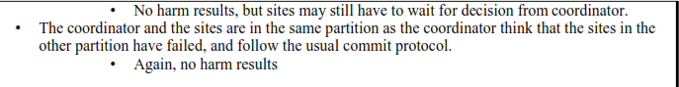

Deadlock
- A deadlock is a condition that occurs when two or more different database tasks are waiting for each other and none of the task is willing to give up the resources that other task needs.
- It is an unwanted situation that may result when two or more transactions are each waiting for locks held by the other to be released.
- In deadlock situation, no task ever gets finished and is in waiting state forever.
- Deadlocks are not good for the system.
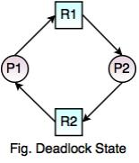
In the above diagram,
- Process P1 holds Resource R2 and waits for resource R1, while Process P2 holds resource R1 and waits for Resource R2. So, the above process is in deadlock state.
- There is the only way to break a deadlock, is to abort one or more transactions. Once, a transaction is aborted and rolled back, all the locks held by that transaction are released and can continue their execution. So, the DBMS should automatically restart the aborted transactions.

Deadlock Conditions
Following are the deadlock conditions,
1. Mutual Exclusion
2. Hold and Wait
3. No Preemption
4. Circular Wait
A deadlock may occur, if all the above conditions hold true.
In Mutual exclusion states that at least one resource cannot be used by more than one process at a time. The resources cannot be shared between processes.
Hold and Wait states that a process is holding a resource, requesting for additional resources which are being held by other processes in the system.
No Preemption states that a resource cannot be forcibly taken from a process. Only a process can release a resource that is being held by it.
Circular Wait states that one process is waiting for a resource which is being held by second process and the second process is waiting for the third process and so on and the last process is waiting for the first process. It makes a circular chain of waiting.

Deadlock can be handled using two techniques –

1. Deadlock Prevention 2. Deadlock Detection and deadlock recovery

1. Deadlock Prevention :
For large database, deadlock prevention method is suitable. A deadlock can be prevented if the resources are allocated in such a way that deadlock never occur. The DBMS analyzes the operations whether they can create deadlock situation or not, If they do, that transaction is never allowed to be executed.
There are two techniques used for deadlock prevention –

(i) Wait-Die :
- In this scheme, if a transaction requests for a resource which is already held with a conflicting lock by another transaction then the DBMS simply checks the timestamp of both transactions. It allows the older transaction to wait until the resource is available for execution.
- Suppose there are two transactions Ti and Tj and let TS(T) is a timestamp of any
transaction T. If T2 holds a lock by some other transaction and T1 is requesting for
resources held by T2 then the following actions are performed by DBMS :

- Check if TS(Ti) < TS(Tj) - If Ti is the older transaction and Tj has held some resource, then Ti is allowed to wait until the data-item is available for execution. That means if the older transaction is waiting for a resource which is locked by the younger transaction, then the older transaction is allowed to wait for resource until it is available.
- Check if TS(Ti) < TS(Tj) - If Ti is older transaction and has held some resource and if Tj is waiting for it, then Tj is killed and restarted later with the random delay but with the same timestamp.

Timestamp is a way of assigning priorities to each transaction when it starts. If timestamp is lower then that transaction has higher priority. That means oldest transaction has highest priority.

For example –

Let T1 is a transaction which requests the data item acquired by Transaction T2. Similarly T3 is a transaction which requests the data item acquired by transaction T2.

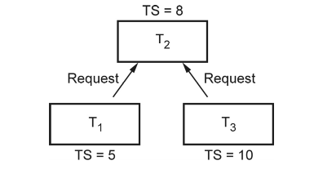
Here TS(T1) i.e. Time stamp of T1 is less than TS(T3). In other words T1 is older than T3. Hence T1 is made to wait while T3 is rolled back.

(ii) Wound- wait :
- In wound wait scheme, if the older transaction requests for a resource which is held by the younger transaction, then older transaction forces younger one to kill the transaction and release the resource. After some delay, the younger transaction is restarted but with the same timestamp.
- If the older transaction has held a resource which is requested by the Younger transaction, then the younger transaction is asked to wait until older releases it.

Suppose T1 needs a resource held by T2 and T3 also needs the resource held by T2, with TS(T1)=5, TS(T2)=8 and TS(T3)=10, then T1 being older waits and T3 being younger dies. After the some delay, the younger transaction is restarted but with the same timestamp.
This ultimately prevents a deadlock to occur.
To summarize

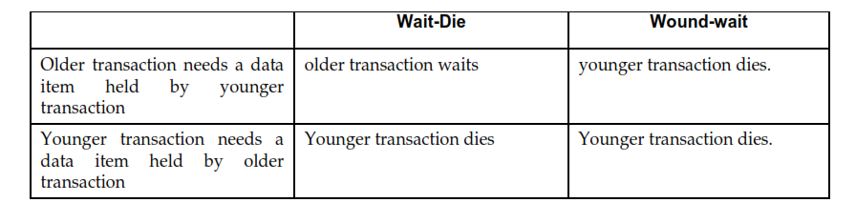
2. Deadlock Detection :
- In deadlock detection mechanism, an algorithm that examines the state of the system is invoked periodically to determine whether a deadlock has occurred or not. If deadlock is occurrence is detected, then the system must try to recover from it.
- Deadlock detection is done using wait for graph method.

Wait For Graph:
- In this method, a graph is created based on the transaction and their lock. If the created graph has a cycle or closed loop, then there is a deadlock.
- The wait for the graph is maintained by the system for every transaction which is waiting for some data held by the others. The system keeps checking the graph if there is any cycle in the graph.
- This graph consists of a pair G = (V, E), where V is a set of vertices and E is a set of edges.
- The set of vertices consists of all the transactions in the system.
- When transaction Ti requests a data item currently being held by transaction Tj , then the edge Ti → Tj is inserted in the wait-for graph. This edge is removed only when transaction Tj is no longer holding a data item needed by transaction Ti
- For example – Consider following transactions, We will draw a wait for graph
for this scenario and check for deadlock.

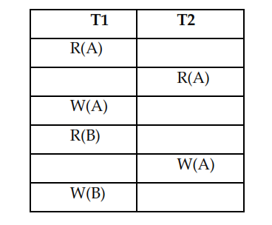

We will use three rules for designing the wait-for graph-
Rule 1: If T1 has Read operation and then T2 has Write operation then draw an edge
T1->T2.
Rule 2: If T1 has Write operation and then T2 has Read operation then draw an edge
T1->T2
Rule 3: If T1 has Write operation and then T2 has Write operation then draw an edge
T1->T2

Let us draw wait-for graph

Step 1 : Draw vertices for all the transactions


Step 2 :
We find the Read-Write pair from two different transactions reading from top to bottom. If such as pair is found then we will add the edges between corresponding directions. For instance -

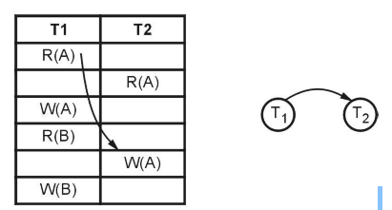

Step 3 :

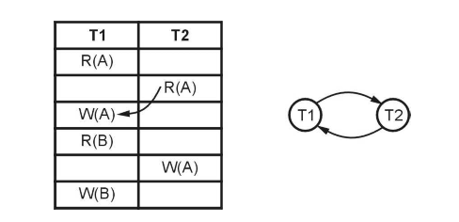
As cycle is detected in the wait-for graph there is no need to further process. The deadlock is present in this transaction scenario.

Deadlock Avoidance
Deadlock Avoidance helps in avoiding the rolling back conflicting transactions.
It is not good approach to abort a transaction when a deadlock occurs.
Rather deadlock avoidance should be used to detect any deadlock situation in advance.

Recovery from deadlock
- The common solution is to roll back one or more transactions to break the deadlock.
- Three action need to be taken
– Selection of victim
– Rollback
– Starvation

Selection of victim
• Set of deadlocked transactions, must determine which transaction to roll back to break the
deadlock.
• Consider the factor minimum cost

Rollback
- once we decided that a particular transaction must be rolled back, must determine how far this
transaction should be rolled back
- Total rollback
- Partial rollback

Starvation
Ensure that a transaction can be picked as victim only a finite number of times.

Transaction Recovery

- An integral part of a database system is a recovery scheme that can restore the database to the consistent state that existed before the failure.
- The recovery scheme must also provide high availability; that means, it must minimize the time for which the database is not usable after a failure.

3.10.1 Failure Classification:

Various types of failures are -

1. Transaction Failure : Following are two types of errors due to which the transaction gets failed.
- Logical Error :
i) This error is caused due to internal conditions such as bad input, data not found, overflow of resource limit and so on.
ii) Due to logical error the transaction can not be continued.
- System Error :
i) When the system enters in an undesired state and then the transaction can not be continued then this type of error is called as system error.

2) System Crash : The situation in which there is a hardware malfunction, or a bug in the database software or the operating system, and because of which there is a loss of the content of volatile storage, and finally the transaction processing come to a halt is called system crash.

3) Disk Failure : A disk block loses its content as a result of either a head crash or failure during a data-transfer operation. The backup of data is maintained on the secondary disks or DVD to recover from such failure.

3.10.2 Storage

A DBMS stores the data on external storage because the amount of data is very huge and must persist across program executions.
The storage structure is a memory structure in the system. It has following categories -

1) Volatile :
- Volatile memory is a primary memory in the system and is placed along with the
CPU.
- These memories can store only small amount of data, but they are very fast. For
example - main memory, cache memory.
- A volatile storage cannot survive system crashes.
- That means data in these memories will be lost on failure.

2) Non Volatile :
Non volatile memory is a secondary memory and is huge in size. For example : Hard disk, Flash memory, magnetic tapes.
These memories are designed to withstand system crashes.
3) Stable :
- Information residing in stable storage is never lost.
- To implement stable storage, we replicate the information in several nonvolatile storage media (usually disk) with independent failure modes.

Stable Storage Implementation:
Stable storage is a kind of storage on which the information residing on it is never lost.
- Although stable storage is theoretically impossible to obtain it can be
approximately built by applying a technique in which data loss is almost
impossible.
- That means the information is replicated in several nonvolatile storage media
with independent failure modes.
- Updates must be done with care to ensure that a failure during an update to stable
storage does not cause a loss of information.

3.10.3 Recovery with Concurrent Transactions
There are four ways for recovery with concurrent transactions :
1) Interaction with concurrency control : In this scheme recovery depends upon the concurrency control scheme which is used for the transaction. If a transaction gets failed, then rollback and undo all the updates performed by transaction.
2) Transaction Rollback : In this scheme, if the transaction gets failed, then the failed transaction can be rolled back with the help of log. The system scans the log backward, and with the help of log entries the system can restore the data items.
3) Checkpoints : The checkpoints are used to reduce the number of log records.
4) Restart recovery : When the system recovers from the crash it constructs two lists : Undo-list and Redo-list. The undo list consists of transactions to be undone. The redo list consists of transactions to be redone. These two lists are handled as follows:

Step 1 : Initially both the lists are empty.
Step 2 : The system scans the log entries from backwards. It scans each entry until it finds
first checkpoint record.

3.10.4 Shadow Copy Technique:
- In the shadow-copy scheme, a transaction that wants to update the database first creates a complete copy of the database.
- All updates are done on the new database copy, leaving the original copy, the shadow copy, untouched.
- If at any point the transaction has to be aborted, the system merely deletes the new
copy. The old copy of the database has not been affected.
- The current copy of the database is identified by a pointer, called db-pointer, which is
stored on disk.
- If the transaction partially commits, it is committed as follows :
- First, the operating system is asked to make sure that all pages of the new copy of the database have been written out to disk.
- After the operating system has written all the pages to disk, the database system
updates the pointer db-pointer to point to the new copy of the database
- The new copy then becomes the current copy of the database.
- The old copy of the database is then deleted.
The transaction is said to have been committed at the point where the
updated db-pointer is written to disk.
The disk system guarantees that it will update db-pointer atomically, as long as we make sure that db-pointer lies entirely in a single sector.
Where is shadow copy technique used ?
- Shadow copy schemes are commonly used by text editors.
- Shadow copying can be used for small databases.

3.10.5 Log Based Recovery Approach:

Log is the most commonly used structure for recording the modifications that as to be made in the actual database. Hence during the recovery procedure a log file is maintained.
A log record maintains four types of operations. Depending upon the type of operations there are four types of log records-
1. <Start> Log record: It is represented as <T, Start>
2. <Update> Log record
3. <Commit> Log record:It is represented as <T, Commit>
4. <Abort> Log record: It is represented as <Ti, Abort>

The log contains various fields as shown in following Fig. 3.13.1. This structure is
for <update> operation
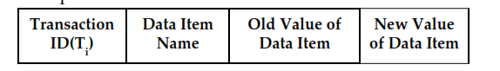
For example : The sample log file is
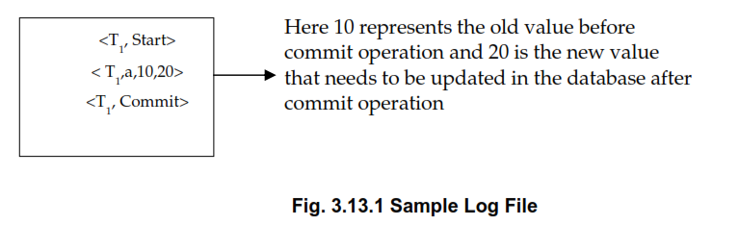

The log must be maintained on the stable storage and the entries in the log file are maintained before actually updating the physical database.

There are two approaches used for log based recovery technique - Deferred Database Modification and Immediate Database Modification.

1. Deferred Database Modification :
• In this technique, the database is not updated immediately.
• Only log file is updated on each transaction.
• When the transaction reaches to its commit point, then only the database is
physically updated from the log file.
• In this technique, if a transaction fails before reaching to its commit point, it will
not have changed database anyway. Hence there is no need for the UNDO operation. The REDO operation is required to record the operations from log file to physical database. Hence deferred database modification technique is also called as NO UNDO/REDO algorithm.

• For example :
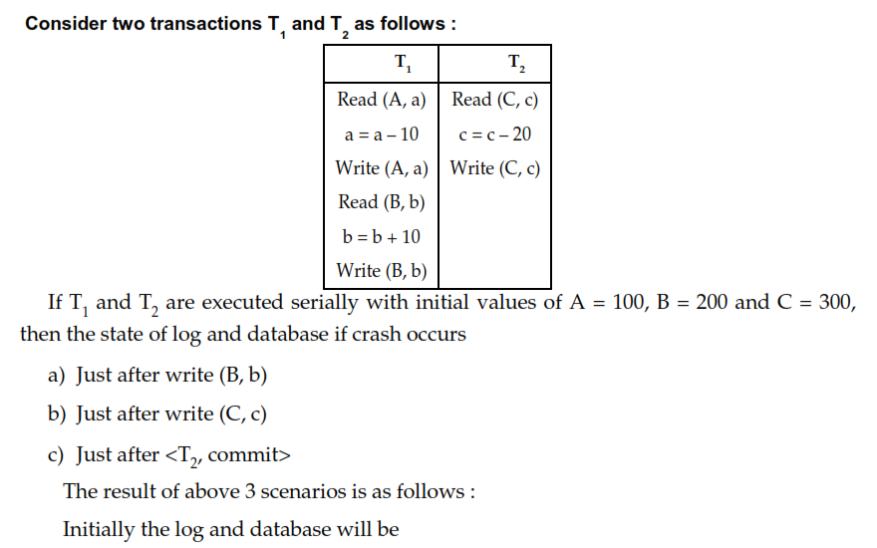
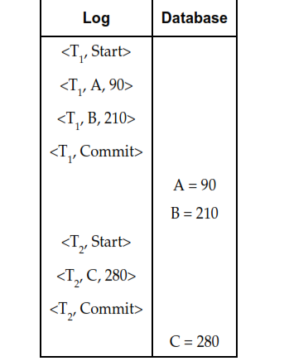
a) Just after write (B, b)
Just after write operation, no commit record appears in log. Hence no write operation is performed on database. So database retains only old values. Hence A = 100 and B = 200 respectively.
Thus the system comes back to original position and no redo operation take place.
can be deleted from log.

The incomplete transaction of T1 can be deleted from log.
b) Just after write (C, c)
The state of log records is as follows
Note that crash occurs before T2 commits. At this point Tis completed successfully, so new values of A and B are written from log to database. But as T1 is not committed, there is no redo (T2 ) and the incomplete transaction T can be deleted from log.

The redo (T1) is done as < T, commit> gets executed. Therefore A = 90, B = 210 and C = 300 are the values for database.
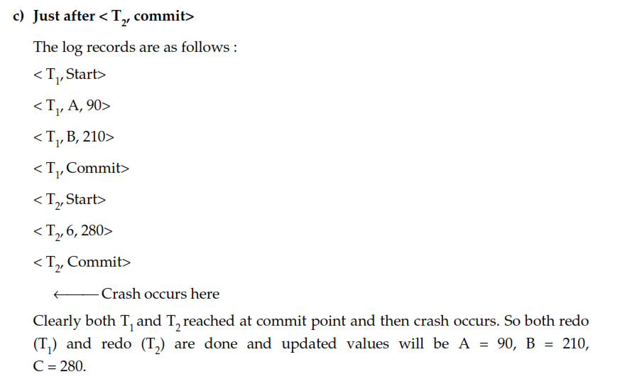
2. Immediate Database Modification :
In this technique, the database is updated during the execution of transaction even before it reaches to its commit point. If the transaction gets failed before it reaches to its commit point, then the a ROLLBACK Operation needs to be done to bring the database to its earlier consistent state. That means the effect of operations need to be undone on the database. For that purpose both Redo and Undo operations are both required during the recovery. This technique is known as UNDO/ REDO technique.
For example : Consider Two transaction T1 and T2 as follows :
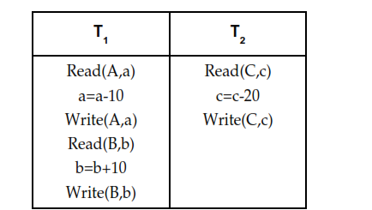
Here T1 and T2 are executed serially. Initially A=100, B=200 and C=300
If the crash occurs after
i) Just after Write(B,b) ii) Just after Write(C,c) iii) Just after <T2,Commit>

Then using the immediate Database modification approach the result of above three scenarios can be elaborated as follows :
The contents of log and database is as follows :
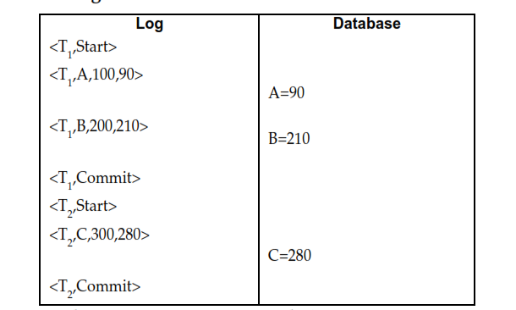
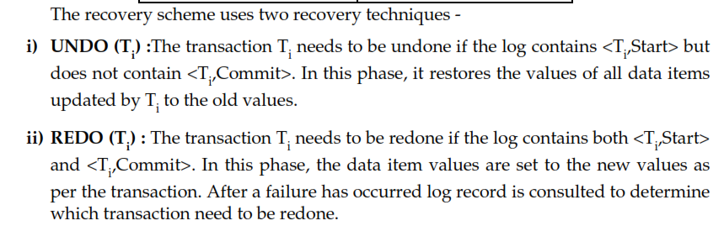
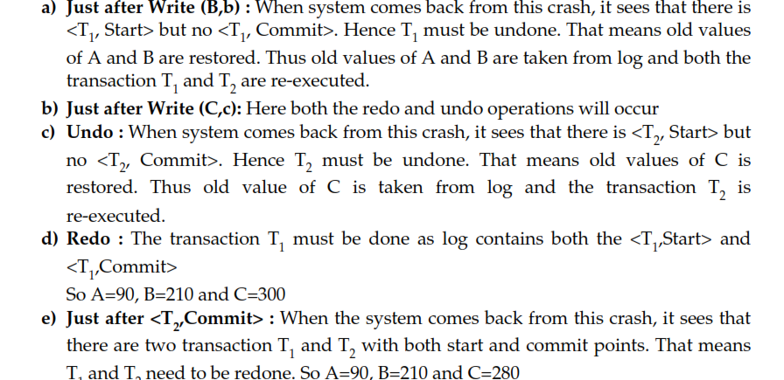
Save Points
A transaction is a unit of work that is performed against a database. Transactions are units or sequences of work accomplished in a logical order, whether in a manual fashion by a user or automatically by some sort of a database program.

Transaction Control
The following commands are used to control transactions.
- COMMIT − to save the changes.
- ROLLBACK − to roll back the changes.
- SAVEPOINT − creates points within the groups of transactions in which to ROLLBACK.
- SET TRANSACTION − Places a name on a transaction.

The SAVEPOINT Command
A SAVEPOINT is a point in a transaction when you can roll the transaction back to a certain point without rolling back the entire transaction.
The syntax for a SAVEPOINT command is as shown below.
SAVEPOINT SAVEPOINT_NAME;
This command serves only in the creation of a SAVEPOINT among all the transactional statements. The ROLLBACK command is used to undo a group of transactions.
The syntax for rolling back to a SAVEPOINT is as shown below.
ROLLBACK TO SAVEPOINT_NAME;
Following is an example where you plan to delete the three different records from the CUSTOMERS table. You want to create a SAVEPOINT before each delete, so that you can ROLLBACK to any SAVEPOINT at any time to return the appropriate data to its original state.
Example
Consider the CUSTOMERS table having the following records.
+----+----------+-----+-----------+----------+
| ID | NAME | AGE | ADDRESS | SALARY |
+----+----------+-----+-----------+----------+
| 1 | Ramesh | 32 | Ahmedabad | 2000.00 |
| 2 | Khilan | 25 | Delhi | 1500.00 |
| 3 | kaushik | 23 | Kota | 2000.00 |
| 4 | Chaitali | 25 | Mumbai | 6500.00 |
| 5 | Hardik | 27 | Bhopal | 8500.00 |
| 6 | Komal | 22 | MP | 4500.00 |
| 7 | Muffy | 24 | Indore | 10000.00 |
+----+----------+-----+-----------+----------+
The following code block contains the series of operations.
SQL> SAVEPOINT SP1;
Savepoint created.
SQL> DELETE FROM CUSTOMERS WHERE ID=1;
1 row deleted.
SQL> SAVEPOINT SP2;
Savepoint created.
SQL> DELETE FROM CUSTOMERS WHERE ID=2;
1 row deleted.
SQL> SAVEPOINT SP3;
Savepoint created.
SQL> DELETE FROM CUSTOMERS WHERE ID=3;
1 row deleted.
Now that the three deletions have taken place, let us assume that you have changed your mind and decided to ROLLBACK to the SAVEPOINT that you identified as SP2. Because SP2 was created after the first deletion, the last two deletions are undone −
SQL> ROLLBACK TO SP2;
Rollback complete.
Notice that only the first deletion took place since you rolled back to SP2.
SQL> SELECT * FROM CUSTOMERS;
+----+----------+-----+-----------+----------+
| ID | NAME | AGE | ADDRESS | SALARY |
+----+----------+-----+-----------+----------+
| 2 | Khilan | 25 | Delhi | 1500.00 |
| 3 | kaushik | 23 | Kota | 2000.00 |
| 4 | Chaitali | 25 | Mumbai | 6500.00 |
| 5 | Hardik | 27 | Bhopal | 8500.00 |
| 6 | Komal | 22 | MP | 4500.00 |
| 7 | Muffy | 24 | Indore | 10000.00 |
+----+----------+-----+-----------+----------+
6 rows selected.

The RELEASE SAVEPOINT Command
The RELEASE SAVEPOINT command is used to remove a SAVEPOINT that you have created.
The syntax for a RELEASE SAVEPOINT command is as follows.
RELEASE SAVEPOINT SAVEPOINT_NAME;
Once a SAVEPOINT has been released, you can no longer use the ROLLBACK command to undo transactions performed since the last SAVEPOINT.

Isolation Level

What is Isolation Level?
To maintain consistency in a database, it follows ACID properties. Among these four properties (Atomicity, Consistency, Isolation, and Durability) Isolation means that a transaction should take place in a system in such a way that it is the only transaction that is accessing the resources in a database system.

Why do we need isolation?
Imagine that you’re implementing a system for large e-commerce. Many operations have to take place at the same time, multiple customers may simultaneously want to purchase the same product, prices of some product may change, new products are still being delivered, etc. As you know, a single action done by a user is run as a transaction in a database, so we need to add some logic to maintain consistency and that’s the role of Isolation because it controls:
- Whether locks are taken when data is read, and what type of locks are requested.
- How long the read locks are held.
- Whether a read operation referencing rows modified by another transaction so it Blocks until the exclusive lock on the row is freed or Retrieves the committed version of the row that existed at the time the statement or transaction started it’s depending on the isolation levels

What is an “Isolation Level”?
Database isolation defines the degree to which a transaction must be isolated from the data modifications made by any other transaction(even though in reality there can be a large number of concurrently running transactions). The overarching goal is to prevent reads and writes of temporary, aborted, or otherwise incorrect data written by concurrent transactions.

A transaction isolation level is defined by the following phenomena :
1. Dirty Read – A Dirty read is a situation when a transaction reads data that has not yet been committed. For example, Let’s say transaction 1 updates a row and leaves it uncommitted, meanwhile, Transaction 2 reads the updated row. If transaction 1 rolls back the change, transaction 2 will have read data that is considered never to have existed.
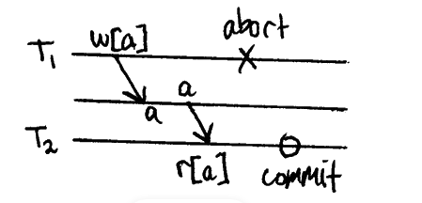
2. Non Repeatable read – Non Repeatable read occurs when a transaction reads the same row twice and gets a different value each time. For example, suppose transaction T1 reads data. Due to concurrency, another transaction T2 updates the same data and commit, Now if transaction T1 rereads the same data, it will retrieve a different value.

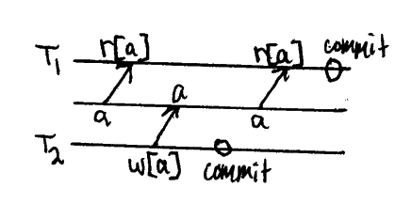
3.Phantom Read – Phantom Read occurs when two same queries are executed, but the rows retrieved by the two, are different. For example, suppose transaction T1 retrieves a set of rows that satisfy some search criteria. Now, Transaction T2 generates some new rows that match the search criteria for transaction T1. If transaction T1 re-executes the statement that reads the rows, it gets a different set of rows this time.

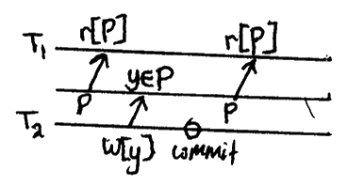

4. Write Skew: Two concurrent transactions each determine what they are writing based on reading a data set that overlaps what the other is writing.
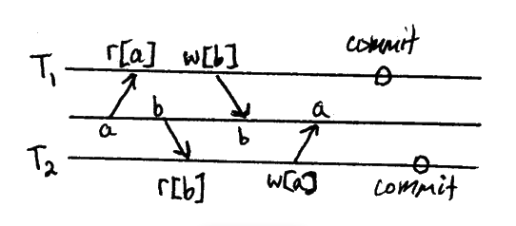
For example, suppose 2 transactions read that x and y have value 100, so individually it’s fine for each transaction to negate one of the values, the total would still be non-negative. However negating both values results in x+y=-200, violating the constraint. For emotional gravity, this is usually framed in terms of bank accounts where account balances are allowed to go negative as long as the sum of commonly held balances remains non-negative.

Based on these phenomena, These four isolation levels have been defined:

1.Read Uncommitted
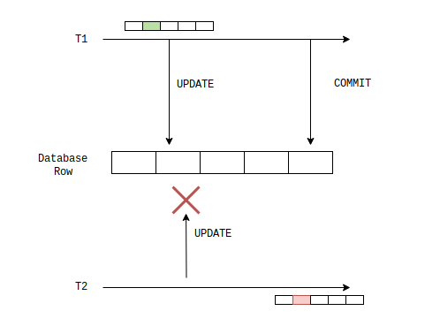
Read Uncommitted is the lowest isolation level. At this level, makes sure no transaction can update a database row if another transaction has already updated it and not committed. This protects against lost updates, but won’t stand in a way of dirty reads
2. Read Committed:
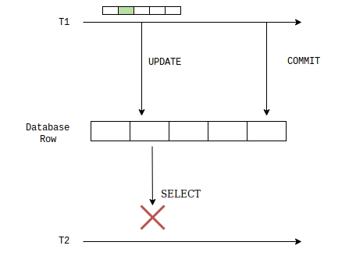
This isolation level does not allow any other transaction to write or read a row to which another transaction has written to but not yet committed. Thus it does not allows dirty read. The transaction holds a read or write lock on the current row, and thus prevents other transactions from reading, updating, or deleting it.

3. Repeatable Read

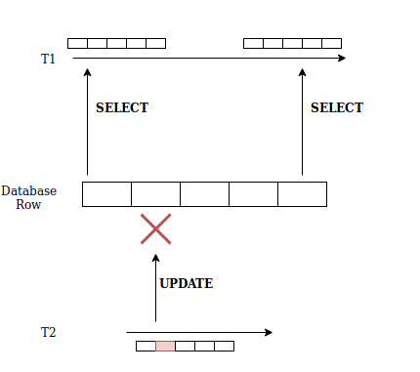
This isolation level makes sure any transaction that reads data from a row blocks any other writing transactions from accessing the same row. This is the most restrictive isolation level that holds read locks on all rows it references and writes locks on all rows it inserts, updates, or deletes. Since other transactions cannot read, update or delete these rows, consequently it avoids non-repeatable read.
4.Serializable:
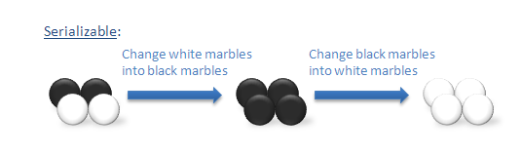
This isolation level is the highest isolation level. serializable isolation level requires a lot more than restricting access to a single row. Typically this isolation mode would lock the whole table, to prevent any other transactions from inserting or reading data from it.
Serializable execution is defined to be an execution of operations in which concurrently executing transactions appears to be serially executing.

5. Snapshot Isolation
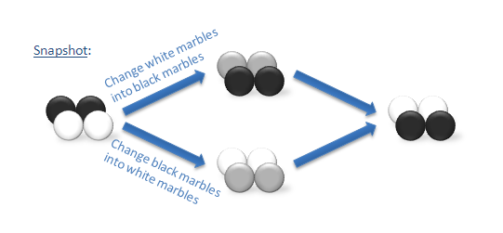
This isolation level can greatly increase concurrency at a lower cost than transactional isolation. When data is modified, the committed versions of affected rows are copied to temp and given version numbers. This operation is called copy on write and is used for all inserts, updates, and deletes using this technique. When another session reads the same data, the committed version of the data as of the time the reading transaction began is returned.
The Table is given below clearly depicts the relationship between isolation levels, read phenomena, and locks :
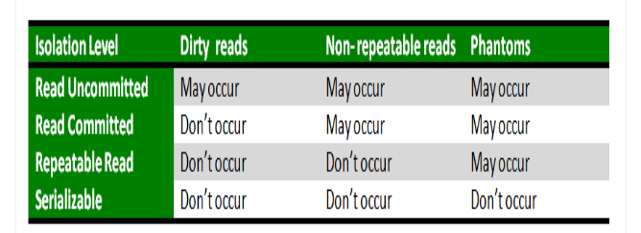

SQL Facilities for Concurrency and Recovery
